**ABSTRACT: FOR SERVERLESS DATA PROCESSING**

* The idea of the smart house has transformed from a sci-fi fantasy to a practical reality in the age of rapid technological innovation. Homeowners may now take advantage of a level of automation and control that was previously unthinkable because to the growth of Internet of Things (IoT) devices and the introduction of artificial intelligence.
* The incorporation of machine learning (ML) models into smart homes, which endows these environments with improved automation and advanced decision-making skills, is a crucial component of this shift. The diverse potential and ramifications of ML integration in smart homes are examined in this abstract.
* A new age in home automation will begin with the incorporation of ML into smart homes. It enables a variety of applications, all of which aim to improve the comfort, effectiveness, and security of our daily life.
* Making tailored experiences possible through the use of ML in smart homes is one of its most significant advantages. These devices are able to pick up on and adjust to the inhabitants’ preferences and routines.
* To provide an unmatched level of comfort and convenience, ML models, for instance, can modify lighting, temperature, and entertainment options based on personal preferences and the time of day.
* Another important area where ML shines is in energy efficiency. ML algorithms can forecast and optimize energy use if they have access to both historical data and current information. With this capacity, a household can save a lot of money and lessen its environmental impact.
* For instance, ML models can figure out when to reduce the temperature or switch off the lights in unused spaces, which would ultimately result in more sustainable energy usage.

**DIAGRAM FOR SEVERLESS IOT DATA PROCESSING:**

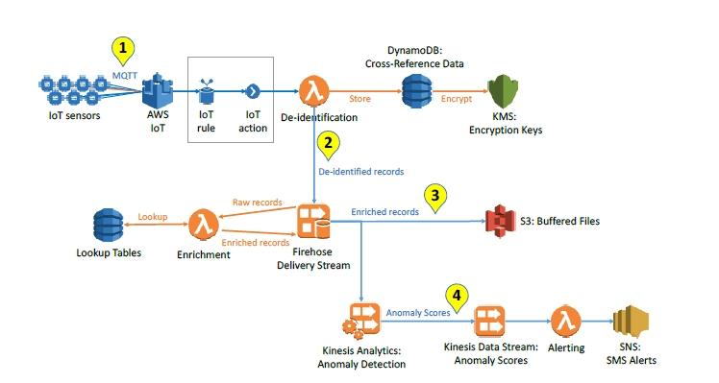

**KEY FEATURES:**

**IOT DEVICE:**

* Sensors, cameras, and other IoT devices are examples of IoT devices that collect data.

**DATA INGESTION:**

* IoT data is absorbed into the system during data ingestion. Cloud-based services like AWS IoT Core and Azure IoT Hub can be used for this.

**SERVERLESS FUNCTION:**

* Use serverless computing services like AWS Lambda, Azure Functions, or Google Cloud Functions to process data using serverless functions. This is where you build the code to handle incoming data and is the primary component of your serverless architecture.

**DATA STORAGE:**

* Processed data may be kept in serverless databases such as Google Cloud Firestore, Azure Cosmos DB, or AWS DynamoDB. It can also be forwarded to data warehouses or lakes for additional analysis.

**EVENT TRIGGERS:**

* Events serve as the triggers for serverless functions. These can be bespoke events created according to the logic of your program, time-based triggers, or data changes.

**SERVERLESS ORCHESTRATOR:**

* Use a serverless orchestrator, such as AWS Step Functions or Azure Logic Apps, to oversee the workflow of various serverless functions and to coordinate multiple serverless activities.

**DATA ANALYSIS AND INSIGHTS:**

* Data Analysis and Insights: Processed data can be evaluated in batch using serverless ETL (Extract, Transform, Load) operations or in real-time using serverless analytics tools.

**Output and Notifications:**

* Use serverless messaging services like AWS SNS, Azure Service Bus, or Google Cloud Pub/Sub to send notifications or alarms based on the studied data to the appropriate stakeholders.

**MONITORING AND LOGGING:**

* Implement serverless monitoring and logging tools to keep tabs on the system’s performance and health. This can be accomplished by using services like AWS CloudWatch, Azure Monitor, or Google Cloud Monitoring.

**Properties**:

* Adaptability
* Efficiency
* Personalization
* Automation
* Scalability
* Real-time Decision-Making
* Predictive Capabilities
* Fault Tolerance
* Learning from Experience
* Interconnectivity
* Security Enhancements

**CONCLUSION:**

The integration of machine learning models into smart homes represents a transformative development in home automation. These systems have the potential to create highly personalized and efficient living environments, from optimizing energy usage to enhancing security and simplifying daily routines. However, the effective deployment of ML in smart homes requires meticulous attention to data quality, model training, and seamless integration with existing devices and infrastructure. As technology continues to advance, the possibilities for smart homes enriched with machine learning are boundless, promising to reshape the way we live and interact with our domestic environments.